**ENHANCING CUSTOMER EXPERIENCE AND SALES THROUGH BI**

**AN AMAZON CASE STUDY**

**Assessment**

Sabaragamuwa University of Sri Lanka

Faculty of Computing

Department of Software Engineering

SE5110 – Business Intelligence

19APSE4307 D.M.N Sandunika

05/08/2024

Contents

Introduction 3

Using BI Tools and Techniques to Analyze the Data 3

1. Data Mining 3

2. Querying 3

3. Dashboards 3

4. Reporting 4

Scenario Description 4

Type of Data 4

Analysis of Amazon Consumer Behavior 5

Browsing Patterns Line Chart 5

Customer Demographics Pie Chart 5

Customer Reviews Importance Column Chart 6

Personalized Recommendation satisfaction Donut Chart 6

Purchase Frequency clustered bar chart 7

Data-Driven Recommendations and Their Benefits 7

Conclusion 9

Data source 9

# Introduction

Evaluating Customers’ behavior is critical in the e-commerce industry knowledge of this behavior is crucial. The current report aims at providing a consumer behavior analysis on the e-commerce giant, Amazon using the Amazon Consumer Behavior Dataset. Some of the contained variables are the purchase frequency, the manner of browsing and the effectiveness of personalized recommendations.

A noteworthy e-commerce company by Jeff Bezos in 1994 known initially as Cadabra before evolving to Amazon has revolutionized shopping online. A vast catalogue of products and services marks the Amazon strategic plan and depend on customer experience analytics.

Here in this report, BI tools and techniques will be employed to dissect customer interaction on Amazon only. The objective here is to look for relationships that can enhance the management’s decisions, the marketing plans, and ultimately, customers’ experience with the product. All of the visuals in the analysis are made using Power BI and consist of specific suggestions for Amazon on how it can enhance its functioning and encourage customers’ engagement.

# Using BI Tools and Techniques to Analyze the Data

In order to examine this data, there are several Business Intelligence tools and approaches that can be applied, such as Power BI. Here’s how these tools and techniques can be utilized: Here’s how these tools and techniques can be utilized:

## 1. Data Mining

Convey frequent and customary features from massive files. Some of the things that should be try to be established are; determining some standardized behaviors that are within different types of customers like; those who make frequent purchases or the ones who rely on the reviews.

## 2. Querying

Get back certain information from the set of records. Use SQL to request data by entering certain parameters, including the average numbers of products of various categories purchased by consumers with different ages.

## 3. Dashboards

Balance the characteristics that require detailed and profound analysis with the elements that can be presented in the form of figures and tables with commentaries. Develop Power BI visuals that are visualizations such as the number of purchases, web visits, and the effects of product suggestions. These dashboards enable the stake holders to check on the overall performance at a glance.

## 4. Reporting

Prepare descriptive Ergebnisse which will be used to make summaries of the analysis. Create insightful reports and analysis with Power BI that describe patterns on customer behavior like the impact of the reviews on the customers’ buying decisions or how effective is the chosen recommendation solution.

# Scenario Description

In this case, there is interest in usage patterns by customers that are using the Amazon facility. The Amazon is one of the biggest online stores globally, and customers’ behaviors are an essential aspect of how marketing methods will be implemented, consumer satisfaction, and subsequently sales enhanced. The chosen scenario refers to analysis of different sides of customers’ interactions with the Amazon: their buying behavior, their navigation, effect of recommendation systems or other customers’ opinions.

Amazon is an American multinational technology company located in Seattle, Washington. Amazon Web Service was established by Jeff Bezos in 1994 and has diversified into e-commerce, digital video/audio streaming, and cloud computing as well as a technological company in AI. The company provides practically everything for millions of its clients; thus it can be considered as a varied business. Hence, accurate data is an essential facet of the company’s operations as it highly relies on big data for better sales, marketing strategies, and organizational management.

# Type of Data

Customer Demographics: In the areas of target consumer classification, age, gender, location, and preferences will be considered so that to make the marketing approach unique to appeal to buyers.

* Sales Transactions: Proliferate records of the various purchases to include date, the category of products, price for the purposes of categorizing the purchase preferences of the customer.
* Website Clickstream Data: Web tracking of the customers’ page views, or the products and services they click on or the paths they take to increase the understanding of customers’ engagement and enhance user experience.
* Customer Reviews and Ratings: Comments on products that are usually made to check the quality of the produced goods, or services offered and satisfaction of the customers.
* Personalized Recommendation Data: Customers data to refine recommendation and customers’ reactions to improve the targeted marketing strategies.
* Browsing and Purchase Frequency: Statistics as to how often customers are likely to Groom themselves and how frequently they shop by age group.
* Shopping Cart and Wishlist Data: Products included but not bought, consumers’ profile is obtained for planned follow-up due to perceived barriers to buy.

# Analysis of Amazon Consumer Behavior

## Browsing Patterns Line Chart

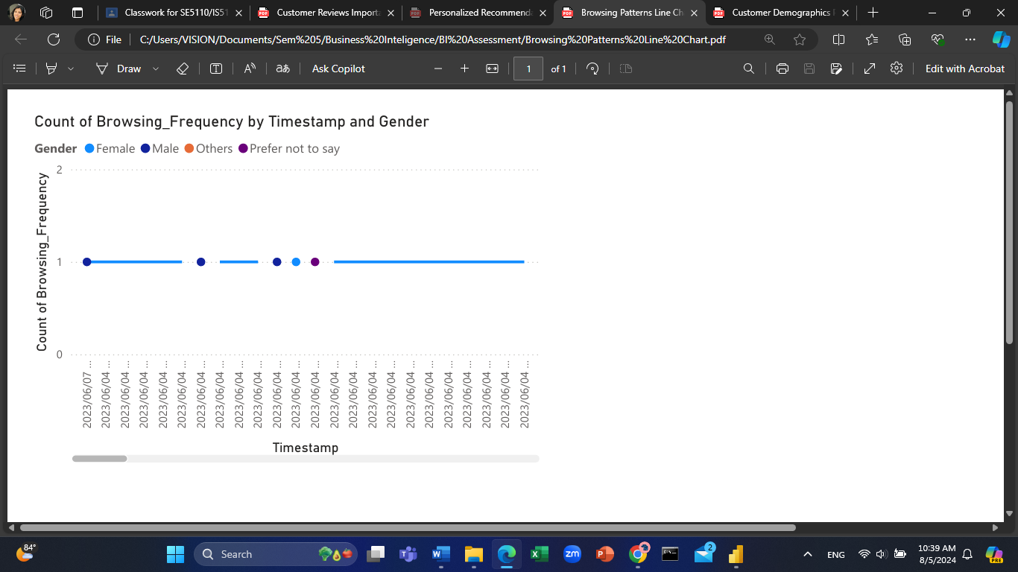 The Line chart on the right is used to show the count of browsing frequency by the timestamp and Gender. It offers a distinct concept on the number of times each gender uses Amazon’s website or application within a given duration. On the part of popularity, there is an equal representation across the genders when it comes to browsing as demonstrated by the line chart. Every pin point can be associated with browsing events detected in the given period and the fluctuations are rather moderate with no high and low points. It helps in comparing the listing of browsing frequency based on gender. What is rather prominent is that all genders are indistinguishable when it comes to browsing behavior, as evidenced by the equal points. The distribution is uniform which implies that there is constant interaction with the platform which in turn can provide information for constant interaction with the customers.

## Customer Demographics Pie Chart

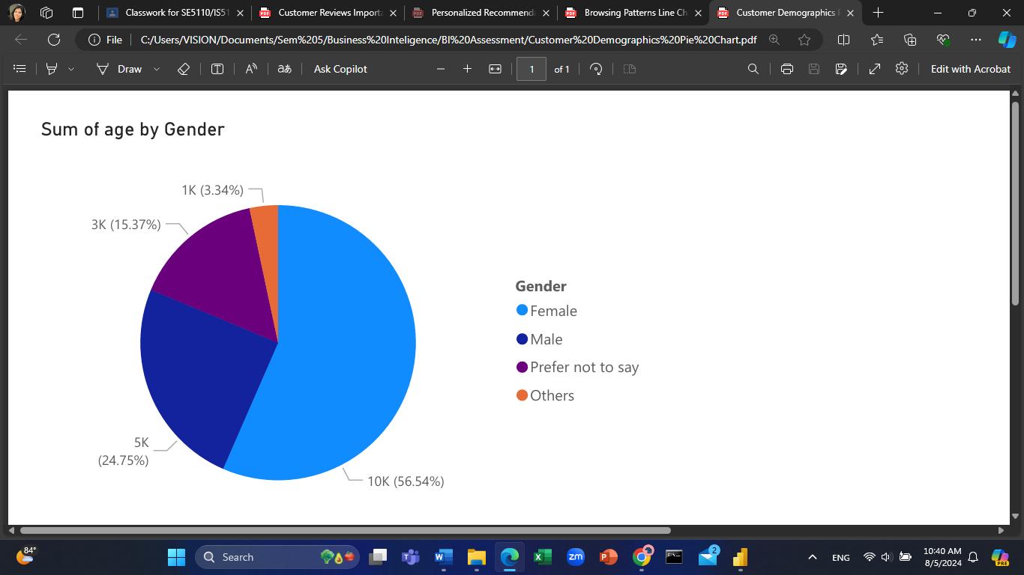 The pie chart shows the sum of age by gender; it provides the demographic split of the customers who shop on Amazon with respect to age and gender. majority of the customers are female thus taking a protruding 56% of the total population. We see in the above-computed arithmetic mean and variance that fifty-four percent of the total sum of age is represented by the initial characters of Chinese. Such a share proves the fact that Amazon customers are mostly females based on the sum of the mentioned parameter. The same can be explained by the fact that 24% of all customers seen by the enterprise are male. They spend a sum equal to 75% of the total sum of ‘age,’ which shareholder believes is less than half the proportion of female customers. Thus, those respondents that Preferred Not to Say and others total 15 out of 350. 37% and 3. Their age corresponds to 34% of the total sum of age, respectively. It points to a group that is relatively limited in size but is significant within the context of the customers.

## Customer Reviews Importance Column Chart

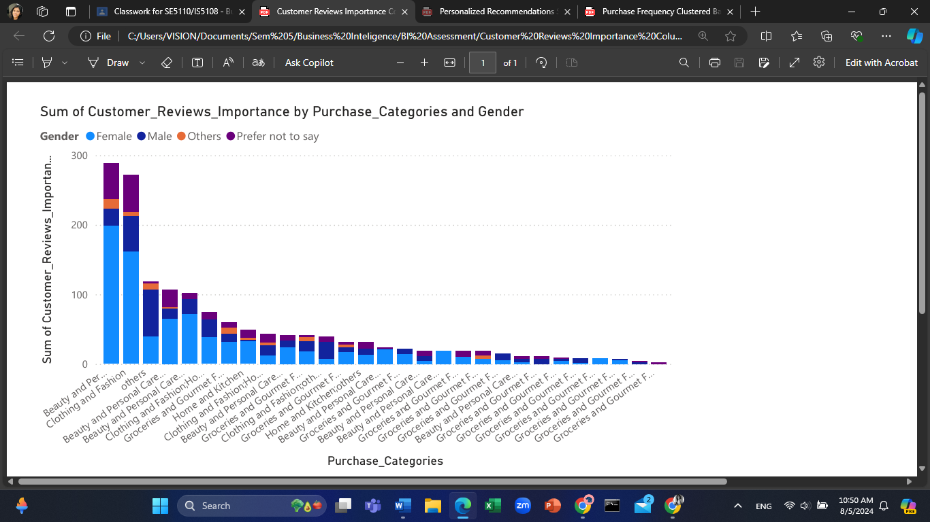

Consequently, it can be seen that Beauty and Personal Care and Clothing and Fashion are the categories of the highest importance of customers’ reviews to all genders. This suggest that these categories remain central to customers as they make their decision to purchase an item, more especially the reviews. seller E revenue seems to be higher for Male relative to other genders, within the top categories, particularly in Beauty and Personal Care and Clothing and Fashion. Like in the case of male customers, female customers also seem to place high importance on these categories, though the bars are just a little lower in combined sense. Both Others and Prefer not to say have much lower values each in each of the purchase categories, which means that those segments of the customers might be less likely to read customer reviews or are a minority in the segment of customers. Groceries and Gourmet Food along with Home and Kitchen, and Electronics are the secondary categories where the customer reviews have a medium relevance. These mentioned categories have slightly better distribution between sexes but in all the reported cases there is a number one man.

## Personalized Recommendation satisfaction Donut Chart

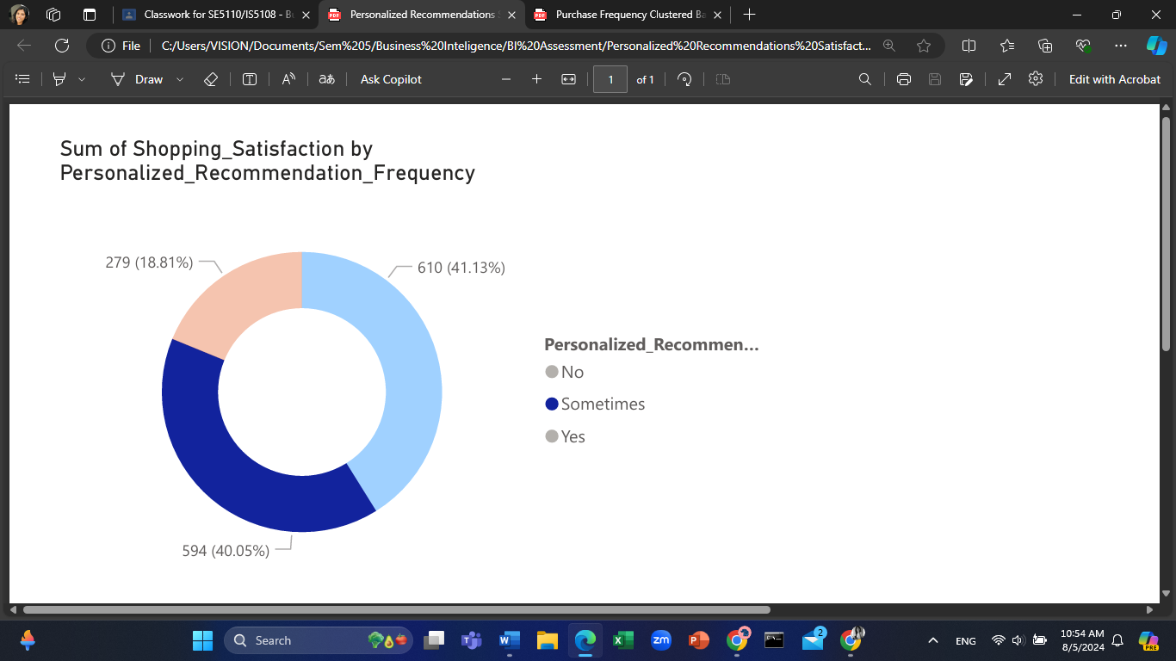

The largest portion of the chart is . 41. 13% and corresponds to the customers, who said “Yes”, thus, this segment can be concluded to have the highest cumulative shopping satisfaction. That is why the presence of constantly received personally targeted suggestions may be an indicator of customer satisfaction with the shopping experience. The “Sometimes” segment is 40 percent of the entire population, according to the survey. 05% of the total. This shows that even clients receiving recommendations from the system occasionally are relatively satisfied despite not as much as the others who receive constant recommendations. The least of them regarded 18. 81% corresponds to the groups of customers who were not offered personalized offers. Thus, this group has the smallest sum of shopping satisfaction, which indicates that the lack of personalization can negatively affect satisfaction.

## Purchase Frequency clustered bar chart

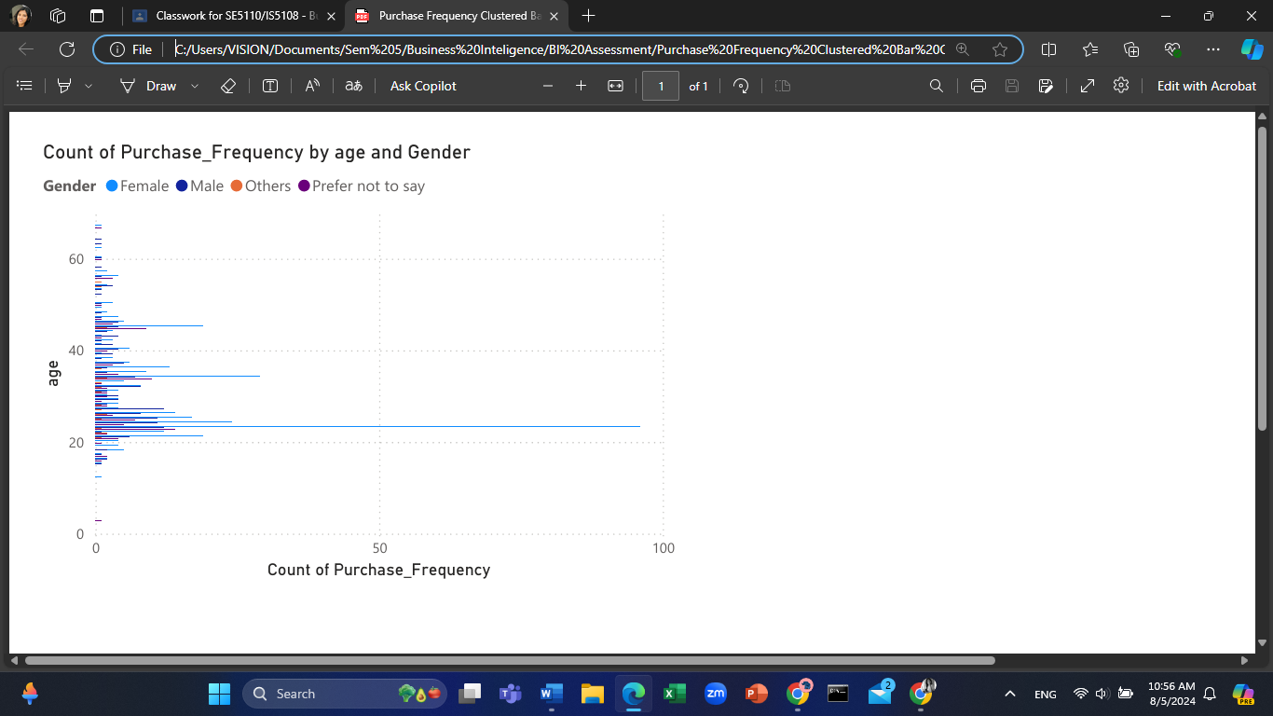The chart also reveals that many purchase frequencies pertain to the young people in the arena of twenty years old. This relates that younger people are more frequent consumers. In terms of the frequency of owning a car, the blue parts depict that the female customers perform better compared to the male customers in most age spans, particularly for the new generation car owners within the age of 20-40 years. This implies that the customers that fall in these age brackets are more likely to be women. Male customers (in red) also frequently used prolific purchase frequency but the market size is smaller and the density in the younger generation is comparatively low to the females. Others and Prefer not to say categories exhibit low percentage of purchase frequency in all the groups, They might be less active or may make up a small fraction of the company’s customer base. Similarly, as the age of the consumer goes above the 40s, the level of purchases’ frequency is lower. This tendency remains the same throughout all the gender categories, which implies that the older customers do not shop as often.

# Data-Driven Recommendations and Their Benefits

Based on the analysis of the five charts created using Power BI, the following recommendations can be made to improve decision-making and potentially benefit the business. Based on the analysis of the five charts created using Power BI, the following recommendations can be made to improve decision-making and potentially benefit the business:

* Line chart demonstrating the result of Browsing Patterns

On the basis of gender and timestamp, users’ browsing patterns provide the knowledge to design and assemble websites according to various groups of people. In other words, with the targeted increase in the usability of the sites during the most frequent listening time and the differences between genders, the level of customer interaction can be amplified.

To the benefit of this, it can be seen that the figure of customers will be increased and their loyalty to the company’s products will also be improved, resulting in better conversion ratios.

* Pie chart of customer demographics

Taking a look at the gender and age, a chart shows a large proportion of the customer base is female. Market related promotions being targeted towards this generational bracket can be improved on the aspect of relevance.

For the sake of this, it is possible to name such outcomes as higher marketing ROI and, as a result, higher sales resulting from more effective advertising.

* Customer Reviews Importance Column Chart

Thus, out of all the products, the customers are most concerned with Beauty and Personal Care, and Clothing and Fashion categories; moreover, men are the most active writing the reviews. Incorporation of review management in these categories and promoting the male customers to provide the reviews could increase their effectiveness.

As the advantages of this WE can mention the following: improved product image, increased confidence, and greater sales in the key areas.

* Shopping with Personalized Recommendation Frequency Donut Chart

Loyal consumers that are always given relevant suggestions have the most indicated satisfaction levels. Cuing up and making Recommendations smarter resulting in better, more frequent and effective shopping recommendations can be beneficial to the complete Shopping Experience.

Regarding the benefits of this we can talk of higher levels of customer satisfaction, their loyalty, as well as higher average order values.

* Purchase Frequency Clustered Bar Chart

Accordingly, the best customers are the youngest ones ranging 20 years and below, with a decreasing trend of purchase frequency with each additional year in age. Specific promotion targeting the young adult audience and techniques to regain the attention of the older people will enhance the sales for all the groups.

And, as the benefit of this it is possible to note more balanced sales rates in answer to different age targets and increased general income in conditions of materialization.

# Conclusion

Therefore, it can be concluded that using Business Intelligence (BI) tools and applying BI techniques to assess Amazon’s customers has been a great benefit as a guideline and an approach. Therefore, when analyzing first-time, repeat, and referral customers’ browsing patterns, customers’ demographics, role of reviews, satisfaction with personalization recommendations, and purchase frequency, potential improvements of customers’ interactions with Amazon can be suggested, as do as well improvements of the business performance. The analytics also include the following recommendations as guidelines: adapting the structure of website navigation to the observed user patterns, implementing the saturation of specific marketing initiatives regarding the dominant audience group, focusing on review solicitation and influencing in the crucial product categories, refining the techniques of customized recommendations, and distributing the marketing attention between different age groups and the segments that appear to be under-represented. The application of such approaches proves to be crucial when it comes to the customer satisfaction and subsequent revenue generation, as well as the achievement of long-term business development objectives. Thus, the usage of BI analytics will help Amazon enhance its competitiveness by responding to new tendencies in customers’ behavior.

# Data source

Amazon consumer behavior data set

The dataset is publicly available and can be accessed

<https://www.kaggle.com/datasets/swathiunnikrishnan/amazon-consumer-behaviour-dataset/data>